Assignment 1 Software Engineer

Instructor: Dr. Adrian Fiech

Group 1:

Demarey Baker

Hanieh Marvikhorasani

Keyvan Derakhshan Nik

1. Provide a description of the project (Vision):

The online voting system is a system that users can login with their ID and Password for electing their elected candidate among number of available candidates by using their cell-phone or computer through internet without going to polling station. This system such as any other system will have an administrator to prepare and create election, users and candidates.

1. Identify the relevant use cases and provide a brief description for them. Create a use case diagram for your system.

The Administrator create and prepare the candidates’ list, the list of users and make the final report. Users login to system and vote once to his/her favourite candidate and after election they can visit the result of election.

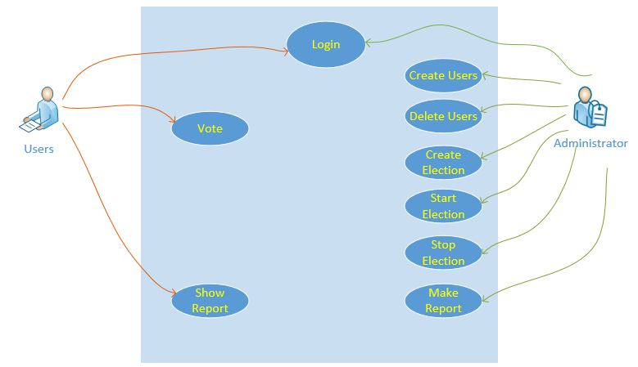

* Administrator create users or delete users
* The administrator creates one election and define the candidates lists and political parties for each candidate and previous vote
* After the creation finished then the administrator starts the election and users can see the vote system
* Users can login to system
* Users can vote one candidate
* At the end the administrator stops the election then users cannot vote
* The administrator makes a report
* Users can log in to click on show report to see the report.

1. Provide a detailed description for three essential use cases.

3-1.Vote Use case:

-It is a list of candidates which has radio button in front and the candidate’s name , last round rank, politic group

-Users can choose one of them

3-2. Login:

-Users and administrator login to the same pages

-Administrator can enter to the dashboard for create user, delete user, create election, start election, stop election make report

-based on the state of election Users can see the voting sheet or show report bottun

3-3. Show report:

-It can create a full report for all candidates votes, percentage, round standing, Total Number of votes.

1. Identify the main conceptual classes, their attributes and associations between them (Domain Modelling)
2. Identify the entity, boundary and control objects in your diagrams.
3. Set up your work environment (Eclipse, Git, …)
4. As a warm up to web application programming, create a simple (single) webpage, in which you add election candidates to a list. Each time the updated list will be displayed in the browser window. Deploy the web page on the departmental server. Provide a url to your page.